Environmental Variable

<https://www.architectryan.com/2018/08/31/how-to-change-environment-variables-on-windows-10/>

<https://www.computerhope.com/issues/ch000549.htm>

Angular

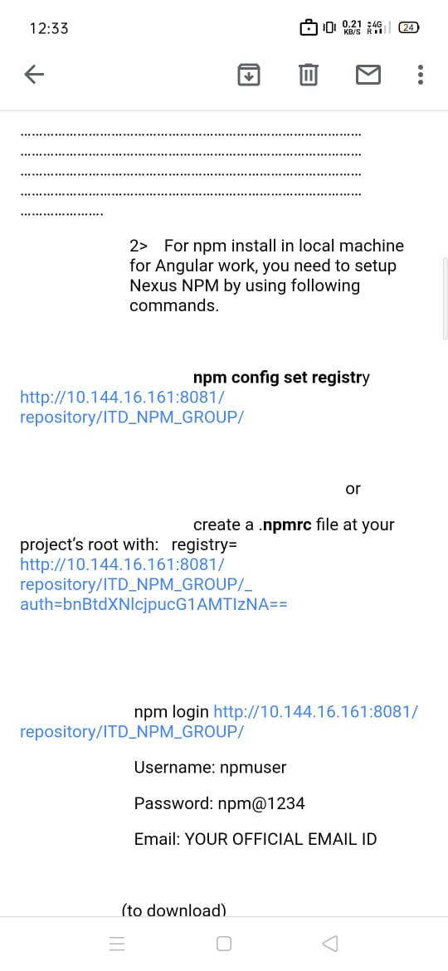

Proxy-url

Npmrc : http://

To set Environmental variable--- pc---right click properties---Advance system settings----admin password--- Environmental variable

Visual studio plugging

